PICK ARSAW COUNTIFY
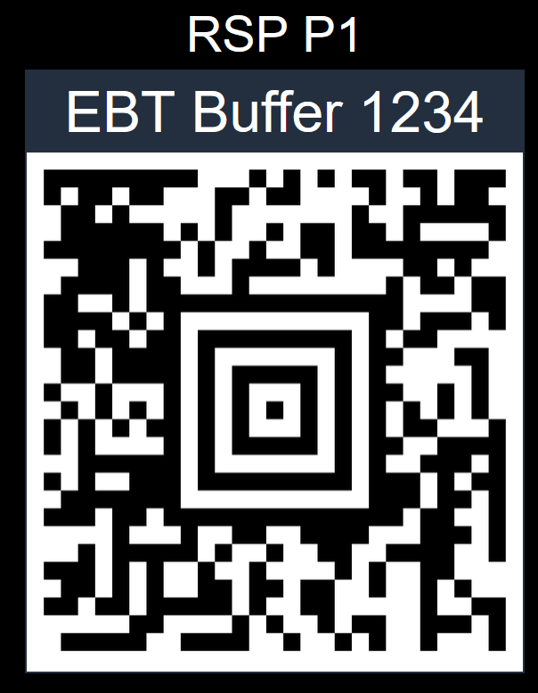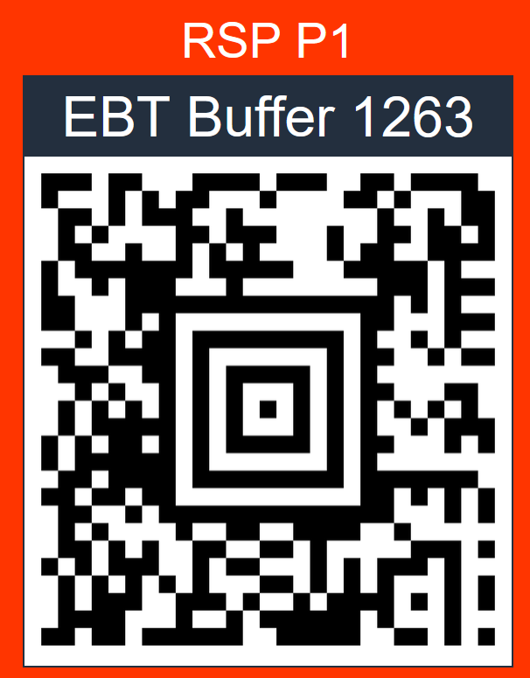
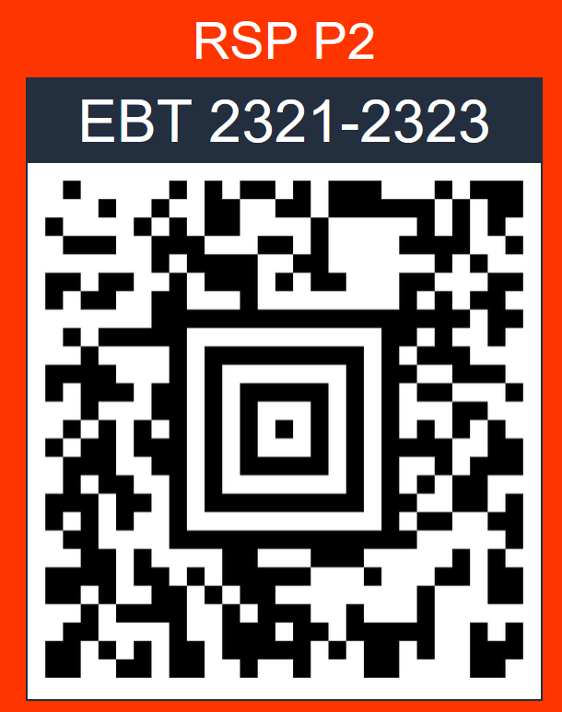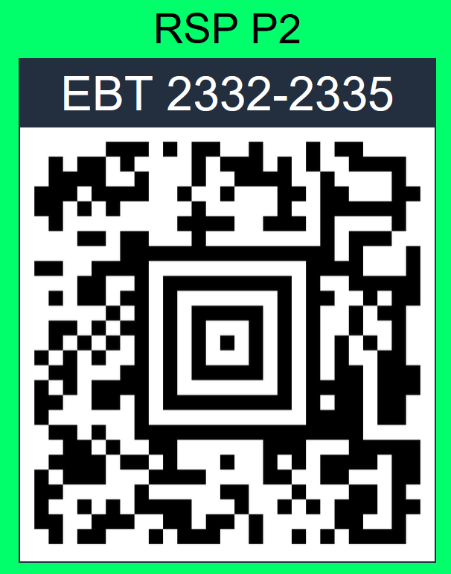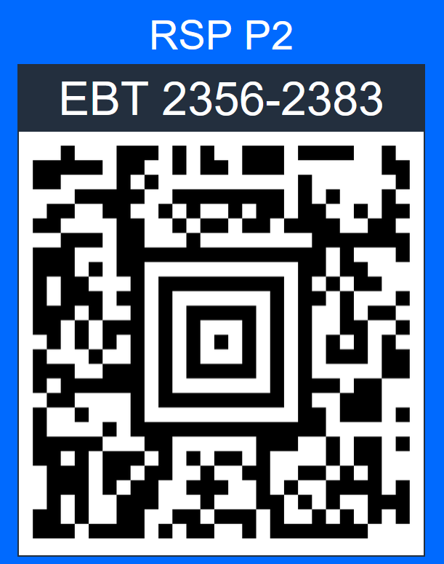
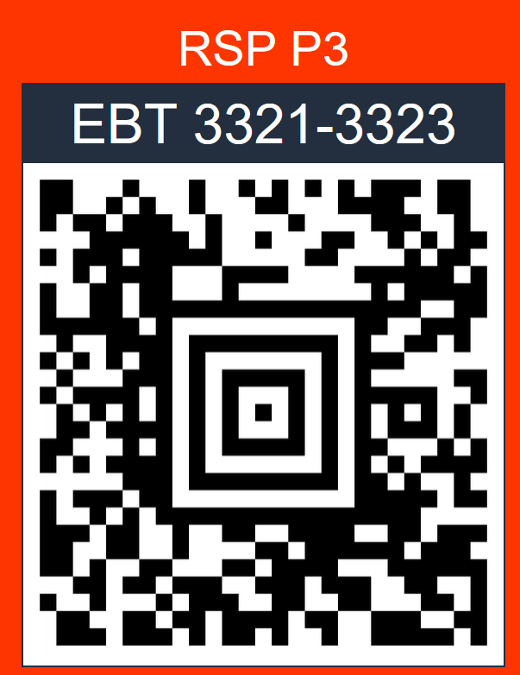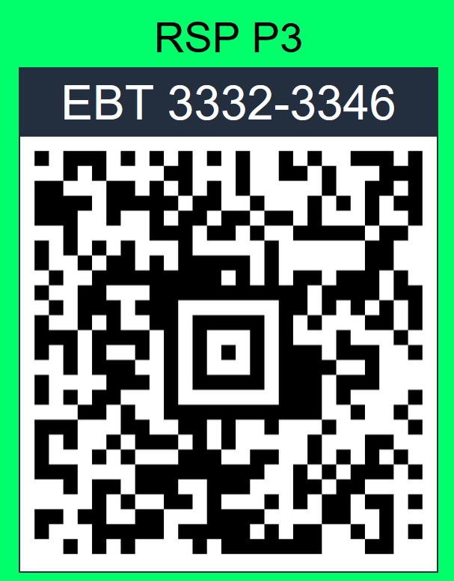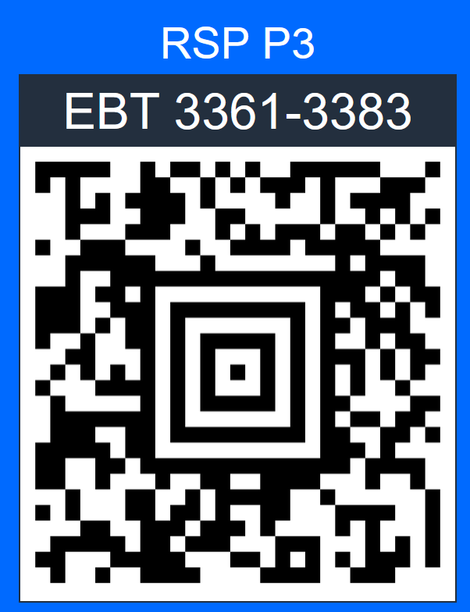

FC Menu: Countify (1367) – ToteMover (1381)
PICK ARSAW COUNTIFY




FC Menu: Countify (1367) – ToteMover (1381)
PICK ARSAW COUNTIFY




FC Menu: Countify (1367) – ToteMover (1381)
PICK ARSAW COUNTIFY




FC Menu: Countify (1367) – ToteMover (1381)
RECEIVE COUNTIFY

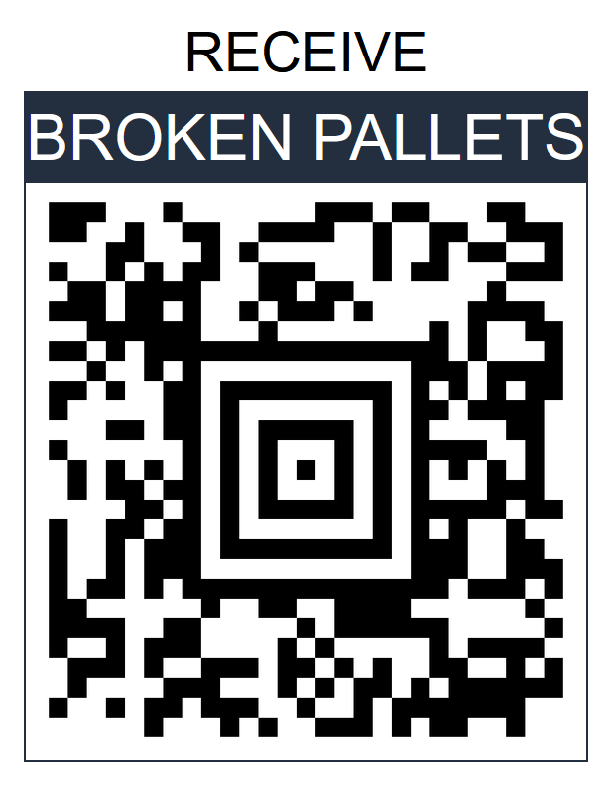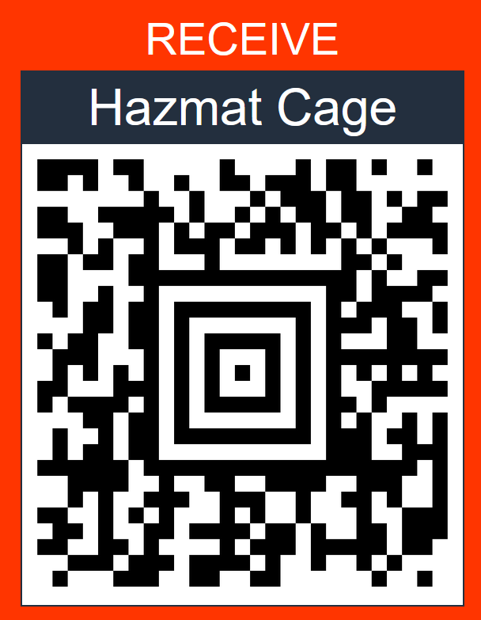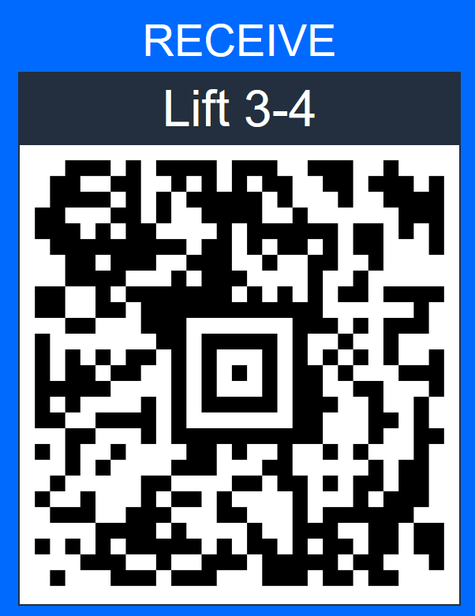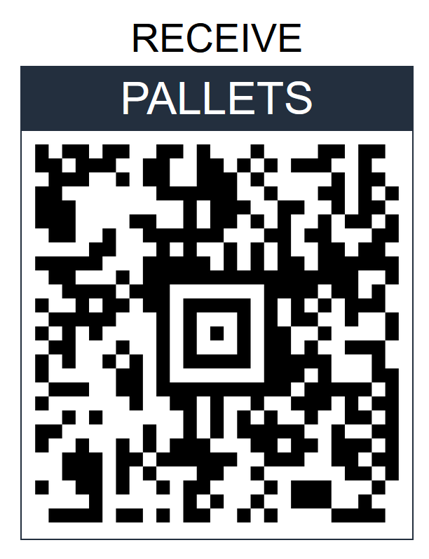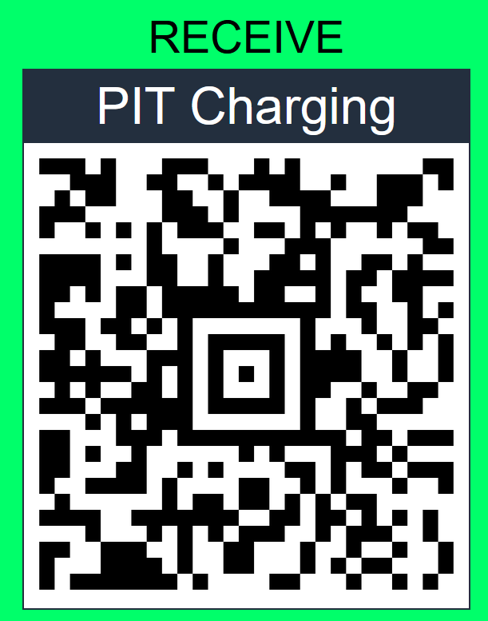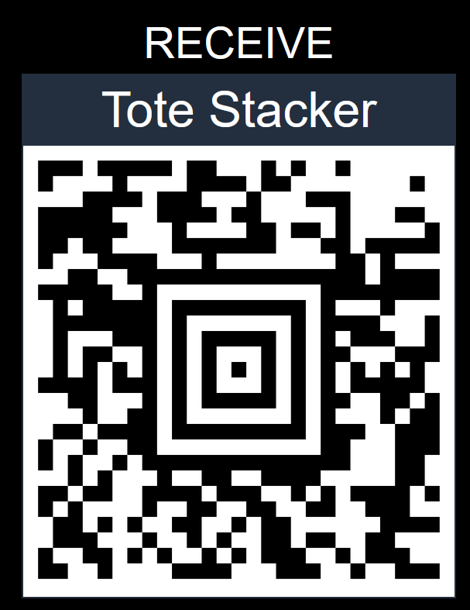

IB DOCK COUNTIFY
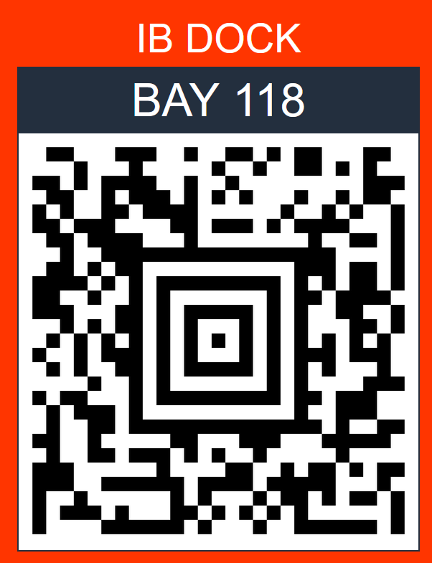

FC Menu: Countify (1367) – ToteMover (1381)

RECEIVE COUNTIFY



IB DOCK COUNTIFY


FC Menu: Countify (1367) – ToteMover (1381)

RECEIVE COUNTIFY



IB DOCK COUNTIFY


FC Menu: Countify (1367) – ToteMover (1381)

RECEIVE COUNTIFY



IB DOCK COUNTIFY


FC Menu: Countify (1367) – ToteMover (1381)

SINGLE MEDIUM COUNTIFY
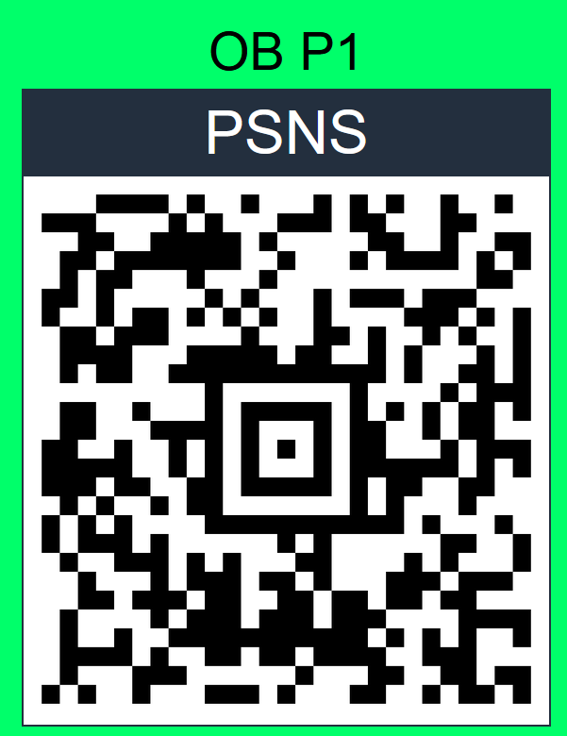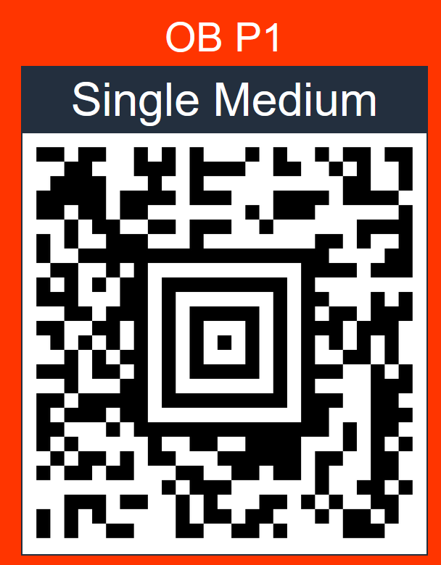

VRET COUNTIFY
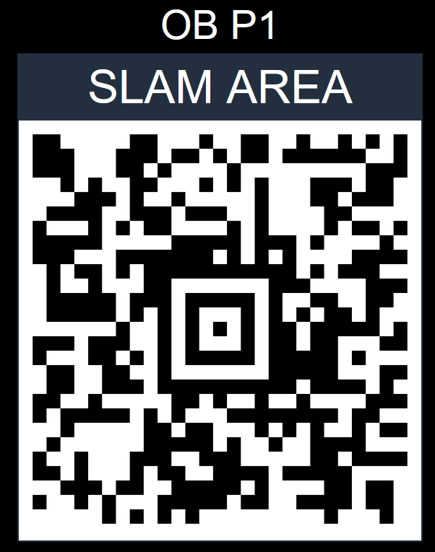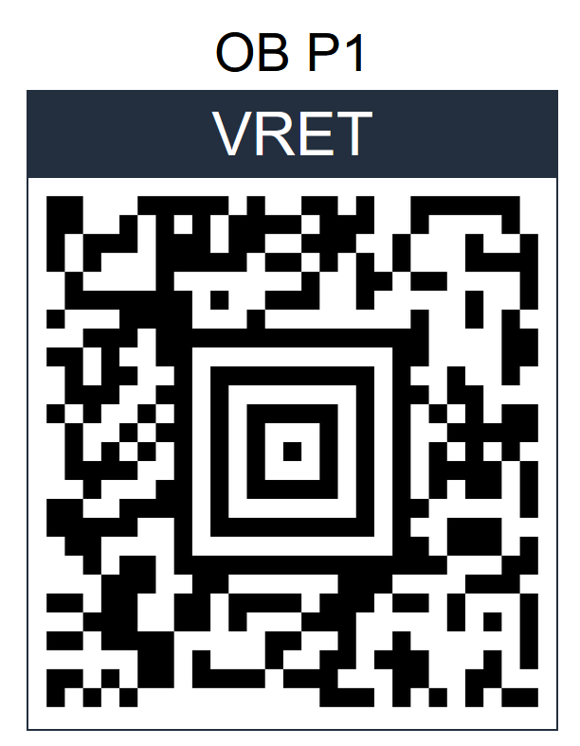

FC Menu: Countify (1367) – ToteMover (1381)

SINGLE MEDIUM COUNTIFY


VRET COUNTIFY


FC Menu: Countify (1367) – ToteMover (1381)

SHIP DOCK COUNTIFY
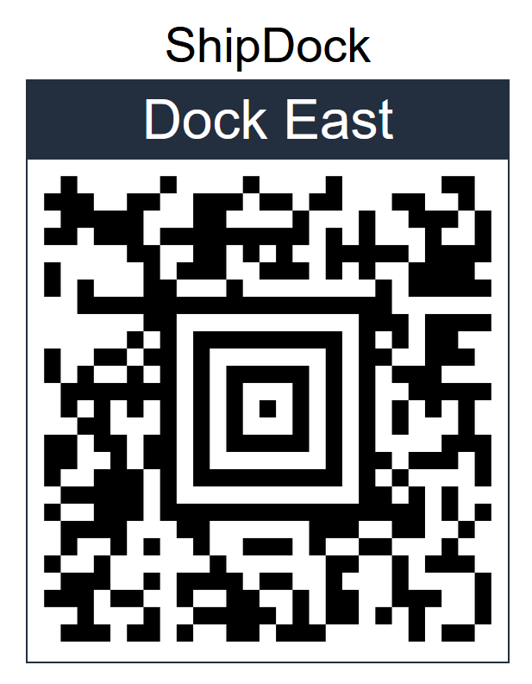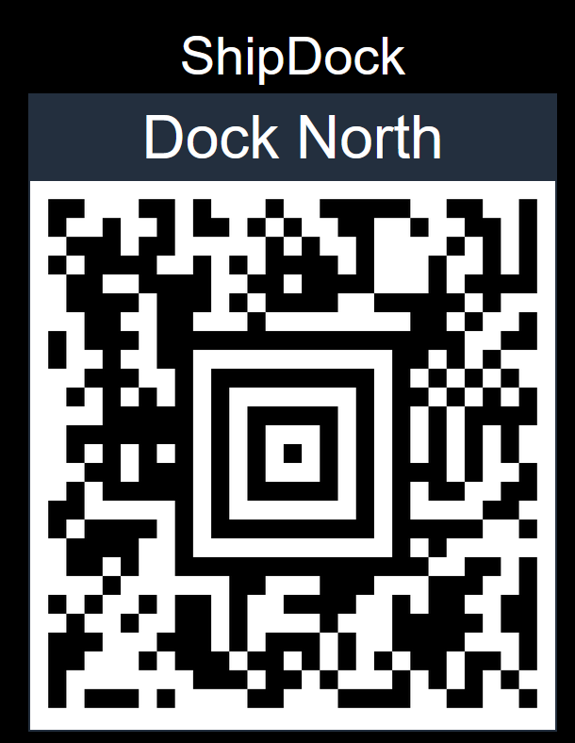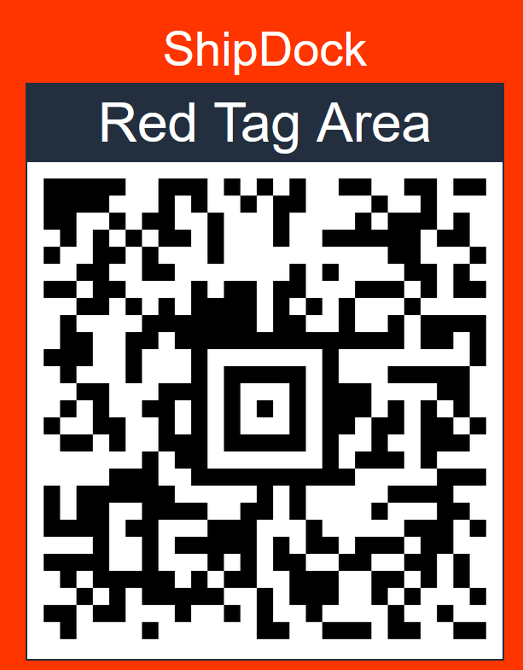

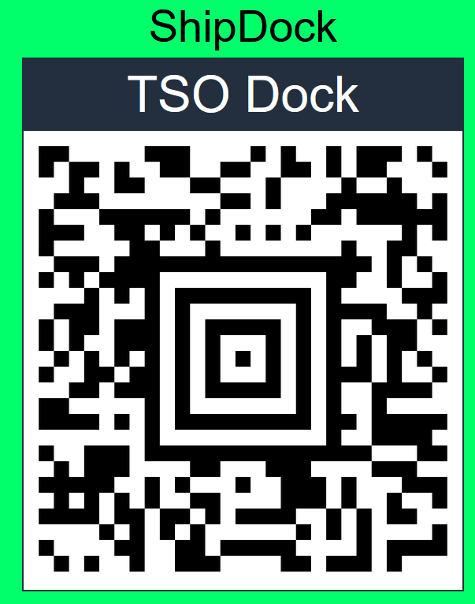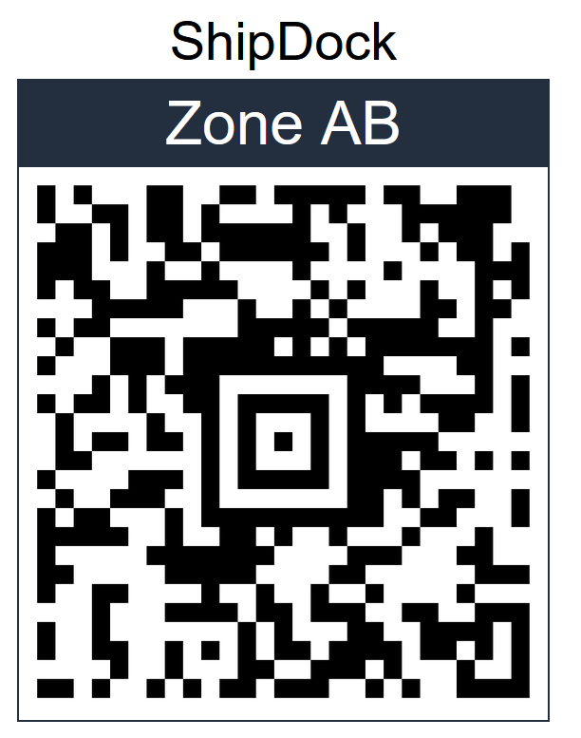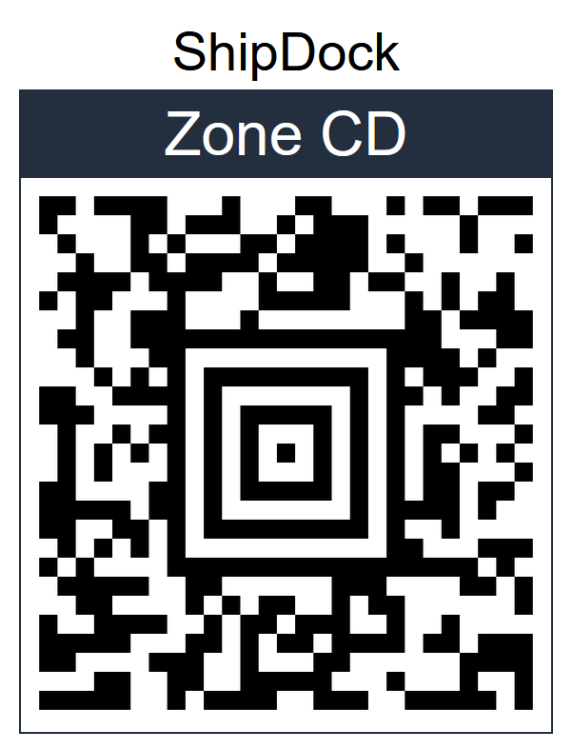

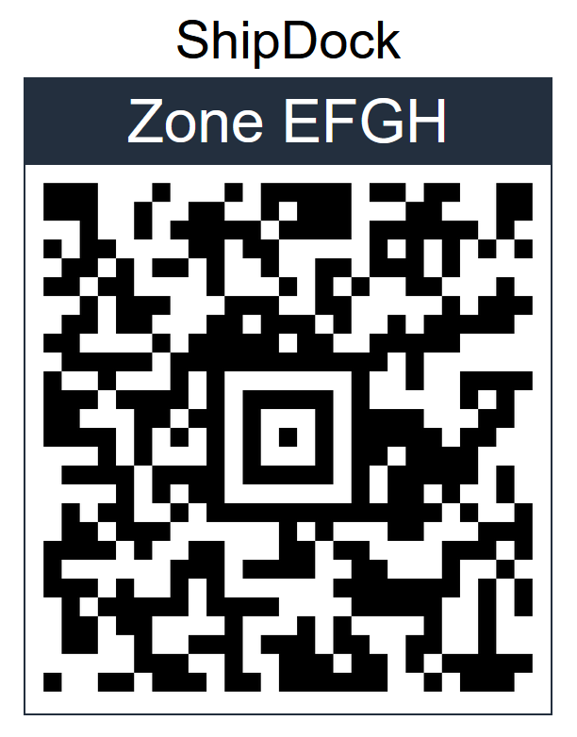

FC Menu: Countify (1367) – ToteMover (1381)
SHIP DOCK COUNTIFY






FC Menu: Countify (1367) – ToteMover (1381)
SHIP DOCK COUNTIFY






FC Menu: Countify (1367) – ToteMover (1381)
SHIP DOCK COUNTIFY






FC Menu: Countify (1367) – ToteMover (1381)

